# Setting up MATLAB

This guide shows you how to setup your MATLAB environment to carry out data analytics and machine learning tasks.

## Setting up MATLAB

You have two options for setting up MATLAB; either using MATLAB through an online web browser along with MATLAB drive; or by installing a local version of MATLAB on your computer.

### Using MATLAB Online

**NOTE**: It is recommended to use Mozilla Firefox or Google Chrome to run MATLAB online.

* Navigate to <https://matlab.mathworks.com/>
* Create a MathWorks account if you do not already have one. Please make sure you use your UCL email address since this will be you access to the campus-wide licence for MATLAB (which in turn gives access to all and full features for MATLAB).
* Once you have registered and signed in to MATLAB Online, you should see an environment similar to the following screenshot:

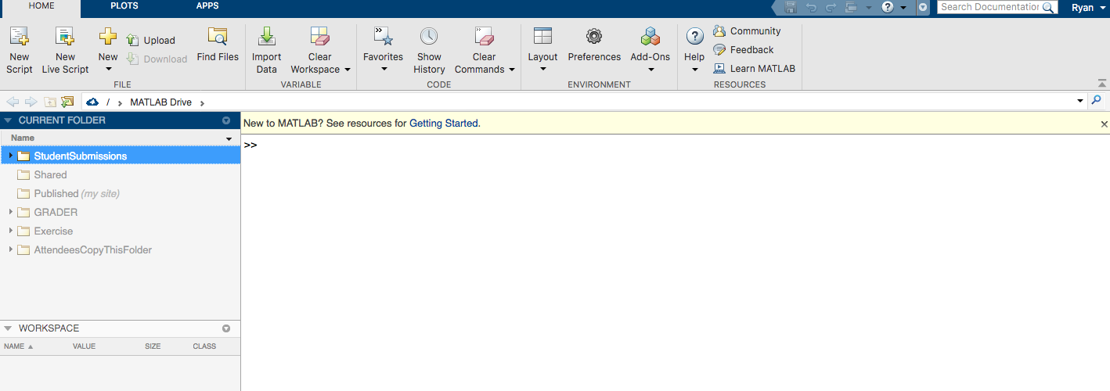

* You will notice that the online environment uses MATLAB Drive. You will have direct access to this once you have setup your MathWorks account. However, to link MATLAB Drive to your desktop (similar for example to Google Drive, Dropbox and so forth), you need to install the MATLAB Drive Connector:

<https://uk.mathworks.com/products/matlab-drive.html?s_tid=AO_MLConnector>

* That’s it! You can now run MATLAB scripts directly in your web browser.

### Using a local version of MATLAB

* If you wish to run a desktop version of MATLAB on your personal computer, you need to download and install it from the following link <https://uk.mathworks.com/downloads/>.
* Make sure you login with your MathWorks account in order to access the UCL campus-wide licence.
* During the installation process, you will have the option of installing the minimum, custom or full version of MATLAB. You can either install the minimum packages to start with and install additional packages as you go along (depending on the requirements of the MATLAB scripts you are running). Alternatively, you can install all the toolboxes and packages, which will give you access to all functions and commands similar to MATLAB Online.